Student Name: ________________________ School: ______________________________
Anticipated Date of Graduation: ______________________
Review Dates: ______________________________________________________________________
Teacher: ___________________________________________________________________________

Please check these as the student/ parent completes
__Social Security Card ___ Driver’s License/I.D. ___Checking/Savings Account
___Birth Certificate ___ Guardianship ___ Register to Vote ___Register for Draft

The following questions will be used to assist in transition planning activities and to determine post-school goals.

1. Where do you want to live after you graduate? Circle your answer.
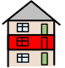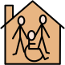
Apartment Supervised Living Family Roommate

2. What skills do you have to maintain your living space? Circle your answer.
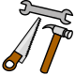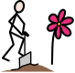
Cleaning Maintenance Yard work
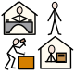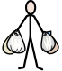
Job Shopping

3. How will you continue learning after graduation? Circle your answer.

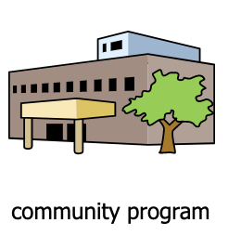
Leisure studies Job Training Volunteer

4. What kind of job do you want while in high school? Circle your answer.
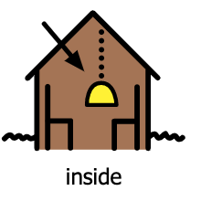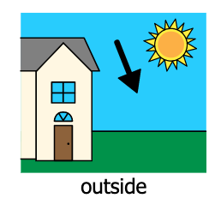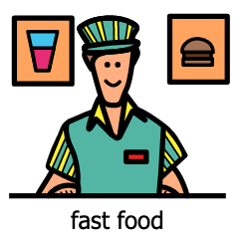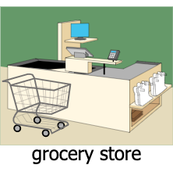

5. What kind of job would you like to know more about? Circle your answer.
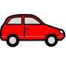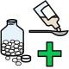
Grocery Office Automotive Medical

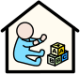
Daycare Retail Cleaning Restaurant

6. What kind of work-related skills do you need for your career after graduation?
problem solving technology writing machine operations

Automotive Social Carpentry Communication

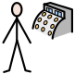
Electrician Cashier Teamwork Interpersonal

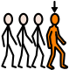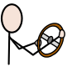
Leadership Driving Reading Decision Making

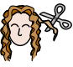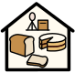
Organizational Cosmetology Barbering Bakery

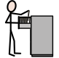Record Keeping

7. What kind of job would you like after graduation? Circle your answer.
Grocery Office Automotive Medical

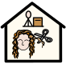
Daycare Retail Cleaning Hair Salon
Restaurant Cosmetology Technology

8. What type of work schedule do you want? Circle your answer.

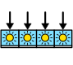
Full time Part time Volunteer Seasonal

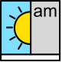 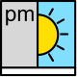 Night 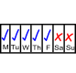 Weekdays 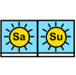Weekends

9. What type of pay and benefits do you want from your future job?
Money Health Insurance Dental
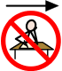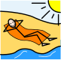
Retirement Vacation

10. What chores/jobs do you do at home? Circle your answer.

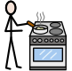
Cooking Shopping Laundry Cleaning Yard Work

11. What are your strengths? Circle your answer.
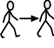
Patient Hard worker On Time Follow Directions

12. What are your weaknesses? Circle your answer.
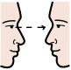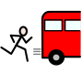
Attention Lateness Talkative Organization

13. What choices do you make now? Circle your answer.
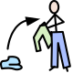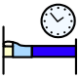
Clothing Food Bedtime
Social Classes Jobs

14. What choices are made for you that you want to take charge of? Circle your answer.
Clothing Food Bedtime Interests
Social Classes Jobs

15. What kind of transportation will you use after graduation? Circle your answer.
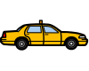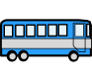
Family member Taxi Public Transportation
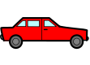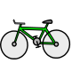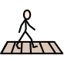
Drive myself Bike Walk

16. Have you taken driver’s education? Check your answer.

Yes No

17. What do you do for fun now? What are your leisure interests? Circle your answer.
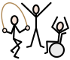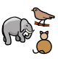
Photography Exercise/Sports Crafts Animals

Building things Computers Games Cooking

18. Who do you spend your free time with?
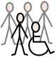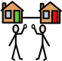
Friends Family Coworkers Neighbors

19. What do you know about managing money after graduation? Circle your answer.

Bank Account Saving money Spending wisely Paying bills

