Student Name: ________________________ School: ______________________________
Anticipated Date of Graduation: _______________ Review Dates: _________________
Teacher: ___________________________________________________________________________

Please check these as the student/ parent completes
__Social Security Card ___ Driver’s License/I.D. ___Checking/Savings Account
___Birth Certificate ___ Guardianship ___ Register to Vote ___Register for Draft

The following questions will be used to assist in transition planning activities and to determine post-school goals.

1. Where do you want to live after you graduate? Circle your answer.
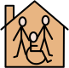
Apartment Supervised Living Family Roommate

2. How will you continue learning after graduation? Circle your answer.

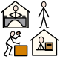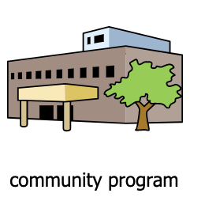
Leisure studies Job Training Volunteer

3. Do you want a job while in high school?

Yes No

4. What kind of job do you want while in high school? Circle your answer.
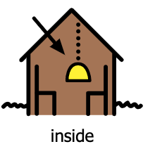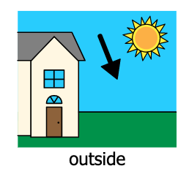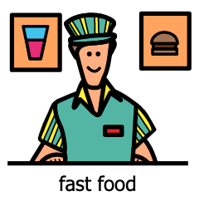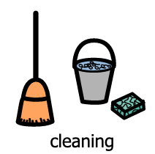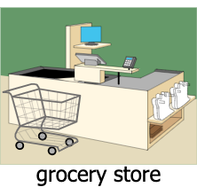

5. What kind of job would like to know more about? Circle your answer.
Grocery Office Automotive Medical

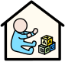
Daycare Retail Cleaning

6. What type of work schedule do you want? Circle your answer.

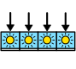
Full time Part time Volunteer Seasonal

7. What chores/jobs do you do at home? Circle your answer.

Cooking Shopping Laundry Cleaning Yard Work

8. What are your strengths? Circle your answer.

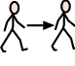
Patient Hard worker On Time Follow Directions

9. What are your weaknesses? Circle your answer.
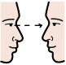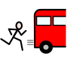
Attention Lateness Talkative Organization

10. Are there any areas of your personal life you are having difficulty with? Circle your answer.
Motivation Peer relationships Drugs/ alcohol Family conflicts

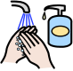
School difficulties Behavior Hygiene

11. What kind of transportation will you use after graduation? Circle your answer.
Family member Taxi Public Transportation
Drive myself Bike Walk

12. What are your hobbies or free time activities? Circle your answer.
Photography Exercise/Sports Crafts Animals

Building things Computers Games Cooking

13. Which of the following are necessary for you to function independently in your community. Circle your answer.
Communication Device Technology Doctor/Therapies Transportation

Advocate Parent Job Home

